Texas Manual on Uniform Traffic Control Devices – Chapter 5 Overview

Traffic Control Devices for Low Volume Roads

Plain Talk About the Texas Manual on Uniform Traffic Control Devices (TMUTCD)

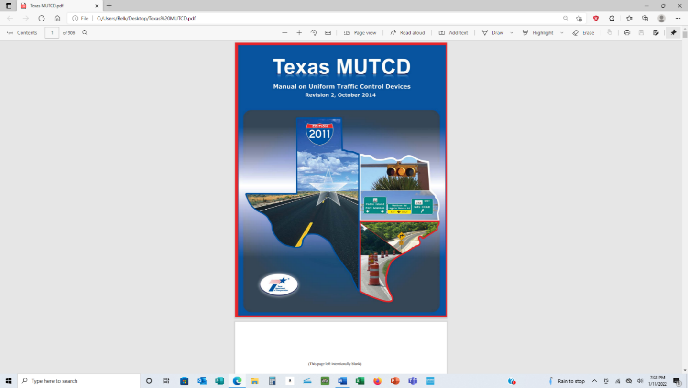
From time to time, officials in cities or counties in Texas are encountered who are under the impression that because they are a county or municipality in the state, they are exempt from the regulatory requirements of the TMUTCD. That belief is entirely wrong. Such belief and practice can subject your city or county to liability if you do not follow the requirements of the TMUTCD when it comes to the various requirements dealing with signs, markers, channelizing devices, traffic control signals, pedestrian signals, school zones, temporary traffic control elements, and the list goes on.

The Texas Manual on Uniform Traffic Control Devices (TMUTCD) is incorporated referenced in the Texas Administrative Code, Title 43, Section 25.1 and shall be recognized as the Texas standard for all traffic control devices installed on any street, highway, bikeway, or private road open to public
travel (see definition in Section 1A.13) in accordance with 23 U.S.C. 109(d) and 402(a). The policies and procedures of the Texas Department of Transportation and the Federal Highway Administration (FHWA) to obtain basic uniformity of traffic control devices shall be as described in 23 CFR 655, Subpart F.

Where cities and counties do get a break from the heavy regulation of signs and markers falls into Part 5 of the TMUTCD titled Traffic Control Devices for Low Volume Roads. A low-volume road shall be defined for this Part of the Manual (Chapter 5A. General) as follows:
A. A low-volume road shall be a facility lying outside of built-up areas of cities, towns, and
communities, and it shall have a traffic volume of less than 400 AADT.
B. A low-volume road shall not be a freeway, an expressway, an interchange ramp, a freeway service road, a road on a designated State highway system, or a residential street in a neighborhood. In terms of highway classification, it shall be a variation of a conventional road, or a special purpose road as defined in Section 1A.13.
C. A low-volume road shall be classified as either paved or unpaved
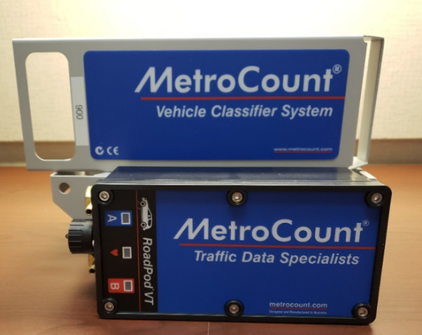
The question that comes into play has to do with 5A. General item A requires the road to have a traffic volume of 400 AADT (Annual Average Daily Traffic) count. The question is, how do you know what the traffic count is on any of your roads? The best way is to conduct an actual traffic count. The TxLTAP has equipment that can be checked out to cities and counties for no cost for a 30-day term. The term can be extended if there is no waitlist for the item. TxLTAP has two MetroCount traffic counters (shown here) available for your use – use them!
Image courtesy of Texas LTAP
Another factor that needs to be considered if you sign and mark according to low volume roads is provided in 5A.01 that states: At some locations on low-volume roads, the use of traffic control devices might be needed to provide the road user limited, but essential, information regarding regulation, guidance, and warning. Other Parts of this Manual contain provisions applicable to all low-volume roads; however, Part 5 specifically supplements and references the provisions for traffic control devices commonly used on low-volume roads. (Section underlined for emphasis)
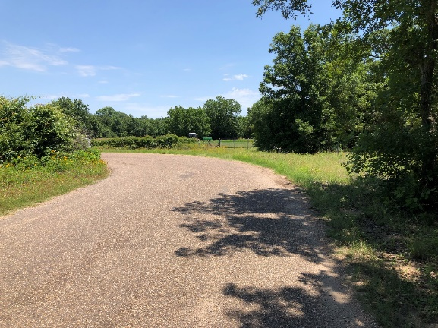
Image courtesy of R. L. Belk Consulting, LLC
Keep in mind that others use your low-volume roads, not just residents that live on them. For example, the picture to the right is from a Texas county. The speed limit is posted at 50 MPH. Do you see any problems that a lack of signage here may present?

Section 5A.02 Application states:
01 It is possible, in many cases, to provide essential information to road users on low-volume roads with a limited number of traffic control devices. The focus might be on devices that:
A. Warn of conditions not normally encountered,
B. Prohibit unsafe movements, or
C. Provide minimal destination guidance.
Standard:
02 The provisions contained in Part 5 shall not prohibit the installation or the full application of traffic
control devices on a low-volume road where conditions justify their use. (Section underlined for emphasis)

It is well served to follow the standard and guidance here as having an unmarked hard left turn at 50 MPH and into a blind corner is a high risk for an accident, which could hold your city or county liable for lack of signage that could have been present.

Also, keep in mind that 5A.01 (C) states: A low-volume road shall be classified as either paved or unpaved. Often some cities and counties are under the impression that any unpaved roads within their jurisdiction are not subject to the TMUTCD. Not so! It applies to all roads in your governmental entity that you maintain.

We will address signage, markings, and temporary traffic control setups on low-volume roads in other Tailgate Talks.

Remember – TxLTAP can provide on-site Technical Assistance to your city or county if you have questions about the signs and markings on your roads. All it takes is a simple phone call to 817.272.9678 or go to www.txltap.org for more information.

